

**Mitsubishi FDTS71KXE6F VRF 1-Way**

**Rs. 122,400/-**

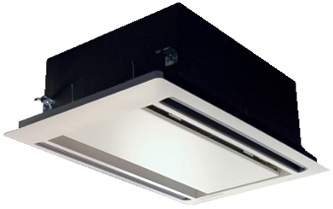

**Product Features**

* Easy Clean Panel
* Remote Control Pocket
* Three Minutes Protection
* Rust Resistant Cabinet
* Reserved Air Outlet

**Specification**

**Type** Ceiling Cassette AC

**Cooling (Btu/h)** 54000

**Voltage (V)** 220-240

**Power Input (W)** 5600

**EER (Btu/W-h-W/W)** 8.1-4.3